Assignment 11
1️. Write a query that uses a subquery to get all orders placed by the customer named Cisneros, assuming you do not know his customer number.
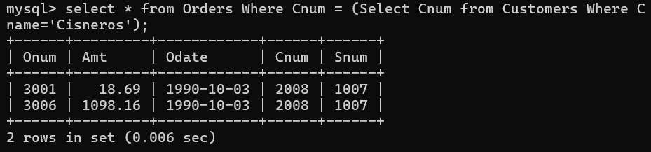

2️.Write a query that returns the names and ratings of all customers whose order amounts are above the average order amount.
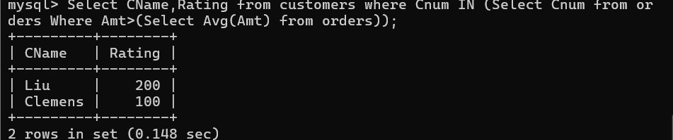

3️.Write a query that finds the total order amount for each salesperson, but only selects those salespersons whose total is greater than the largest single order in the entire orders table.
